12.58: (a) Get radius of 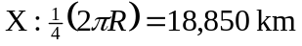
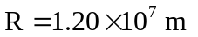

Astronant mass: 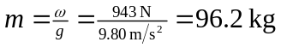Use astronant at north pole to get mass of X:
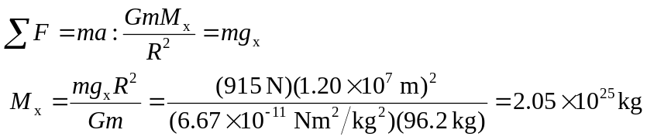
Apply Newton’s second law to astronant on a scale at the equator of X.
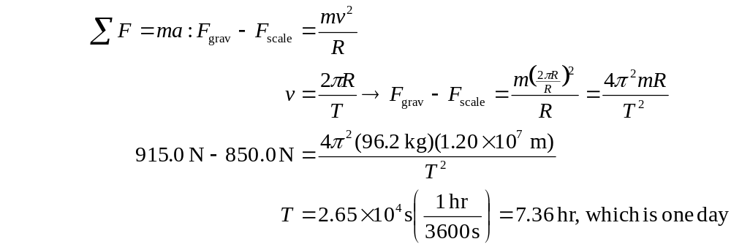
(b) For satellite:
